**ASSIGNMENT 02**



(Master of Business Administration)

**MITTAL SCHOOL OF BUSINESS**

**Annexure-V- Cover Page for Academic Tasks**

|  |
| --- |
| **Course Code: MGNM578**  **Course Title:** International Business Environment. |
| **Course Instructor: Manmeet Kaur Kukreja** |
| **Academic Task No.: 02**  **Academic Task Title:** MACRO-ENVIRONMENT ANALYSIS OFJAPAN |
| **Date of Allotment: 22/09/2022 Date of submission: 04/10/2022** |
| **Student’s Roll no: RQ2240A14 Student’s Reg. no: 12202342** |

# SUBMITTED BY: GROUP 3

|  |  |  |  |
| --- | --- | --- | --- |
| **Sl.no** | **Name** | **Roll number** | **Peer rating** |
| **1.** | **Soumoditta Dey** | **RQ2240A13** | 10 |
| **2.** | **Nowneesh T** | **RQ2240A14** | 10 |
| **3.** | **Muskan Kumari** | **RQ2240A15** | 10 |
| **4.** | **Piyush Sudesh Yadav** | **RQ2240A16** | 10 |
| **5.** | **Lakhaveer Singh** | **RQ2240A19** | 10 |
| **6.** | **Muskan Guddu** | **RQ2240A20** | 10 |

**Declaration:**

I declare that this Assignment is my individual work. I have not copied it from any other student’s work or from any other source except where due acknowledgement is made explicitly in the text, nor has any part been written for me by any other person.

**Student’s Signature**- Nowneesh T (**RQ2240A14**).

# Evaluator’s comments (For Instructor’s use only)

Evaluator’s Signature and Date:

Marks Obtained: ___________

Max. Marks: …………………

**EXECUTIVE SUMMARY:**

A macro environment refers to the set of conditions that exist in the economy as a whole, rather than in a particular sector or region. In general, the macro environment includes trends in the gross domestic product (GDP), inflation, employment, spending, and monetary and fiscal policy. The macro-environment is closely linked to the general [business cycle](https://www.investopedia.com/terms/b/businesscycle.asp) as opposed to the performance of an individual business sector. The macro-environment refers to the broader condition of an economy as opposed to specific markets.

* The macro-environment can be affected by GDP, fiscal policy, monetary policy, inflation, employment rates, and consumer spending.
* The state of the macro environment affects business decisions on things such as spending, borrowing, and investing.

When thinking about a particular idea or plan, it provides a bird's eye view of the entire environment from all the different angles that one wants to check out and keep track of it. There are certain questions that one needs to ask while conducting this analysis, which gives them an idea of what things to keep in mind. They are:

* What is the political situation of the country and how can it affect the industry?
* What are the prevalent economic factors?
* How much importance does culture have in the market and what are its determinants?
* What technological innovations are likely to pop up and affect the market structure?
* Are there any current legislations that regulate the industry or can there be any change in the legislations for the industry?
* What are the environmental concerns for the industry?

The significance of each aspect may vary depending on the type of industry, but conducting the MACRO environmental analysis is essential for any business to inter in the international market to know that what are the condition which can affect the import and export of the country it is dealing with.

Political factors are an example of a macro-environmental force that can impact a business. These include laws or government regulations governing companies or the industry in which they operate.

For example, a government can enact [tariffs](https://www.investopedia.com/articles/economics/08/tariff-trade-barrier-basics.asp) that increase the cost of an imported good a company needs to manufacture its products. Rather than paying the tariff, the company can look for a domestic source for these goods that is cheaper than the imported good. If they can't find a domestic source, they will have to purchase the more expensive imported goods. In many cases, the company will need to pass the additional cost on to the consumer in the form of increased product prices. This could reduce the company's revenue if sales decrease because of the company's higher prices.

**OVERVIEW OF JAPAN**

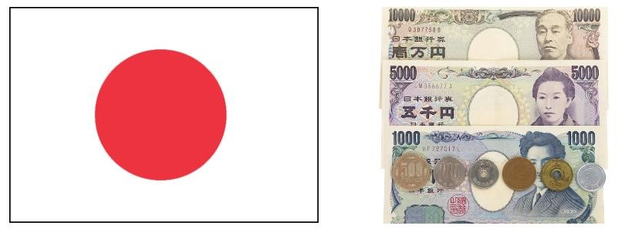On the eastern tip of Asia, Japan is an archipelago, or group of islands. There are also approximately 4,000 smaller islands! The Siberian area of Russia is Japan's closest neighbour on the continent, whereas Korea and China are farther south. Nearby, three of the tectonic plates that make up the Earth's crust intersect and frequently rub against one another, producing earthquakes. Every year, Japan is struck by more than a thousand earthquakes. Around

200 volcanoes may be found in Japan, 60 of which are active.

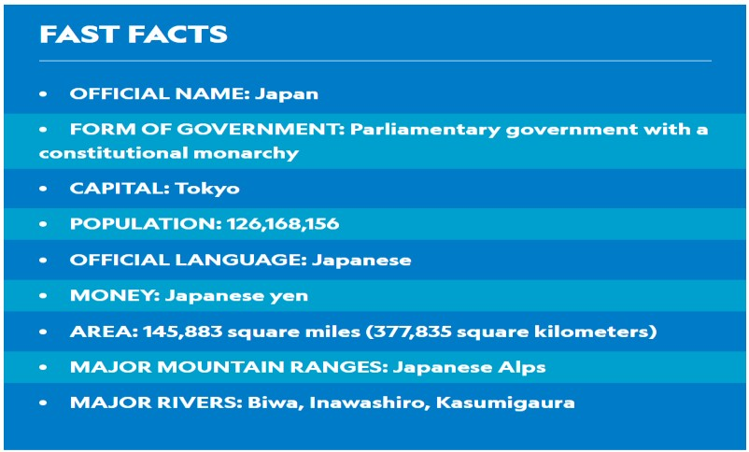Japan was first inhabited roughly 30,000 years ago. People used to cross the main islands on foot since Siberia and Korea were connected to them by dry-land bridges at the time. Around 12,000 years ago, the Jomon civilization, the first society, emerged. In the same period, the Ainu people arrived by boat from Siberia. The Japanese are renowned for their willingness to put in a lot of effort. Respect for others, especially parents and superiors, is taught to children. They develop the ability to put the demands of their family or business before their own. Western and Japanese cuisine are significantly distinct from one another. There is little meat, but there is a lot of rice, fish, and veggies. This diet, which has very little fat or dairy, is exceptionally healthful and contributes to Japanese people living, on average, the longest lives in the world. The beauty of the countryside is deeply cherished by the Japanese people. Natural phenomena like mountains, waterfalls, and forests are said to have spirits or souls according to the antiquity Shinto religion. Although pollution is now strictly regulated, road construction and other human endeavors have devastated natural areas. In Japan, 136 species are classified as endangered.

The only other nation in the world having an emperor in power is Japan. Emperors are regarded as a representation of the nation's traditions and unity despite having no real authority.

The second World war ruined Japan's economy. But the diligent effort and creative ingenuity of the Japanese people turned it around, making it the second-largest economy in the world. Some of the most well-known electronic products are produced by Japan's high-tech sector.

Global Data predicts that the Japanese economy will expand by 2.9% in 2022, while household consumption will increase by 0.9%.

In the GCRI Q4 2021, Japan was placed 15th out of 136 countries. In 2022, it is anticipated that the Japanese automobile market would resume its upward trajectory and experience a rebound in both output and exports.

**MACRO-ENVIRONMENT ANALYSIS:**

**CULTURAL & SOCIETAL ANALYSIS OF JAPAN**

In a globalized economy, cultural sensitivity is essential. As more companies grow, and the global marketplace becomes more accessible for small businesses, multinational and cross-cultural teams are becoming more common. This means that it is crucial, now more than ever, for businesses to understand the culture of their foreign market if they wish to succeed internationally.

[Culture](https://en.oxforddictionaries.com/definition/culture) is the ideas, customs, and social behavior of a particular person or society, but how does culture affect international business in Japan? Below we are going to analyze.

Japan had a score of 0.919 out of 100 in the UNDP's Human Development Report (2020), which ranks it 19th out of the 189 nations examined. Japan is above the regional average and is classified as having very high human development, according to the East Asia and Pacific region's average human development score for 2019, which was 0.747. Shintoism and Buddhism are two major religions while the major language is Japanese which is spoken by around 99% of the country’s population.

By the age of 30, Japanese women are expected to settle down and get married. She might have worked up to that time, but after she got married, it was assumed that she would stop working. At least one kid who can 'inherit' the family's wealth and/or assets is anticipated to be born to the marriage. The structure is patriarchal. Over the past few years, however, birth rates between monogamous couples have been quite low.

According to them, they created the stage for Japanese nationalism, which also created the perception of foreign working practice. This determines how they view foreign products and services as well as how they feel about women and their coworkers in the workplace.

The Japanese emphasize the tea-drinking ritual's procedure over its consummation. Every working method that is used in their company and culture reflects this. Additionally, there is a stronger tendency to work as a group than as an individual. In other words, they support conforming work ethics more so than they do entrepreneurial culture. Due to this, they are forced to work for the same corporation their entire lives rather than producing a business.

Working as a team and acting in accordance with society's norms are more appropriate. The fundamental framework of Japanese working procedures has been as follows. As a result, the workplace now has a strong hierarchical structure.

The tenth most populous nation in the world is Japan. Other sources, however, place it 11th in the globe rather than 10th. There are currently 126.2 million people there (Worldometer, 2021). The two main faiths of Japan are Shintoism and Buddhism, and the majority language, said by around 99% of the people, is Japanese.

Many societal issues confront Japan. The two major problems Japan is currently facing are an ageing population and a declining birthrate. Men may expect to live 81 years on average, compared to 87 years for women. According to several estimates, the population of Japan will probably be less than 100 million by 2045-2050 and 87 million in 2060. Japan will suffer a great deal from this, and regional countries, especially China, will get the upper hand. As a result, many Japanese lawmakers are increasingly emphasising the need for a "integrated" immigration strategy to bring in necessary foreign employees and close the skill gaps brought on by Japan's ageing and declining birth rate.

Japanese businesses are frequently valued above international ones in Japan. Trading becomes challenging for international businesses as a result. Indeed, this is a major factor in the failure of many foreign businesses in Japan. For instance, Tesco (a British retail behemoth) had to shut down its business in Japan in 2012 after being there for nine years (BBC, 2012). Similar to how Wendy's, Pret A Manger, and several other international businesses failed in Japan. It is also true, though, that certain foreign businesses prospered greatly in Japan. Therefore, it is crucial for foreign businesses to conduct a thorough environmental analysis before entering Japan.

Due to technological advancements, both large, multinational firms and SMEs now have greater access than ever before to the worldwide market. Due to the rise of cross-cultural teams in the workplace as a result of increased globalization, businesses now more than ever need to comprehend cultural differences, especially if they hope to be successful in international trade.

In Japan, communication is highly complicated. It's crucial to comprehend both verbal and nonverbal communication since spoken words might have several meanings. The understanding of what is stated depends on the context. Since verbal communication may be perceived in so many different ways, nonverbal communication is crucial. Even the simplest phrase may alter how something is understood.

Japan is a country with a dynamic, diverse culture that has many opportunities for commercial investment and creativity. From their extensive rituals to the way they interact, the Japanese are an extremely complicated civilization.

Money seldom exchanges hands directly in Japan, which has an influence on commerce as well. This implies that you won't give the cashier your money when you make a transaction. Instead, you should use the tiny tray that is supplied to place your payment (cash or credit card). If modification is required, it will also be put here for you. In hotels, restaurants, and taxis, you may anticipate literally running into this method because it is so common in Japan.

**Problems facing:**

Many societal issues confront Japan. The two major problems Japan is currently facing are an ageing population and a declining birthrate. Men can expect to live 81 years on average, compared to 87 years for women. According to many estimates, the population of Japan will probably be less than 100 million in 2048 and 87 million by 2060. Japan will suffer a great deal from this, and regional powers, especially China, will get the upper hand. As a result, many Japanese lawmakers are now emphasizing the need for an "integrated" immigration policy to bring in necessary foreign employees and close the skill gaps brought on by Japan's ageing and declining birth rate.

Japanese businesses are frequently preferred above foreign ones in Japan. Trading becomes challenging for international businesses as a result. This is undoubtedly one of the primary causes of the failure of many foreign businesses in Japan. For instance, Tesco (a British retail behemoth) had to shut down its business in Japan in 2012 after being there for nine years (BBC, 2012). Similar to how Wendy's, Pret A Manger, and numerous other international businesses failed in Japan. It is also true, though, that certain foreign businesses prospered greatly in Japan. Therefore, it is crucial for foreign businesses to conduct a thorough environmental analysis before entering Japan.

Create and maintain business relationships according to the culture & societal:

Japan suggests that it is possible to identify essential Japanese cultural values in business that it is necessary to understand in order to create and maintain business relationships with Japanese people.

* The significance of connections: Individuals are viewed in the context of their social relationships in traditional Japanese culture. In Japan, relationships are fundamental to society, and all forms of interpersonal interaction are governed by a complex set of variations in social standards.
* Reputation maintains: One of the most significant cultural practices in Japan may be maintaining one's dignity in front of others as well as oneself. The Japanese have a propensity to seek out appropriate ways to adjust their preferences to those of others in order to avoid upsetting or damaging their reputation.
* Self-Restraint and discipline: Japanese people will make every effort to maintain their composure and discipline in a crisis. The ability to suppress one's sentiments, emotions, and behaviors in any circumstance is referred to as self-control. The ability to stick to what one believes is right in the face of temptations to do differently is referred to as selfdiscipline.
* Striving towards excellence: A cultural trait that is reflected in the typically high level of quality and service in Japan is the pursuit of perfection in even the smallest aspects. Although it is acknowledged that perfection is not always feasible, it should always be tried. Therefore, perfecting a technique by continual repetition is insufficient, and attempting to achieve a condition of no-mind is vital.
* Flexibility: The most amazing mind is like water, because water is changing its shape to fit any surroundings. Avoiding attachments and being able to adjust to new circumstances are two ways to be flexible. It's essential to let go in a world that is always changing.
* The significance of the environment: The setting is crucial because appropriate behavior should always be expected, regardless of the situation. No action is good or evil in and of itself; rather, the meaning and values of any given action are fully dependent upon the context, intent, timing, and location. The best actions are those that humans demonstrate.
* Social order and regard for age: The Confucian idea of social hierarchy, which outlines the duties and obligations that regulate relationships between people, is the foundation of Japanese society's vertical structure. Respect for the elderly and showing deference to seniority are two of the most crucial.
* The value of adhering to societal norms: The Confucian idea of li encompasses both ethical standards for thinking, feeling, and behaving in addition to the standardized activities of daily living.

# POLITICAL AND LEGAL ANALYSIS OF JAPAN

Japan is a constitutional monarchy with a parliamentary regime. The head of State is the emperor and the role is largely ceremonial. The leader of the majority party or leader of the majority coalition in the parliament (House of Representatives) is designated as the Prime Minister for a four-year term. Immigration, gender equality, and job protections are all tough issues, and the LDP is split on all of them. Then there are the difficult questions about how Japan will change its energy mix to address the challenge of climate change and lingering concerns about the safety of its nuclear power plants.People can work in Japan as employees, dispatched workers, independent contractors, and directors. All employees enjoy employment rights and benefits such as maximum work hours, work breaks, holidays, and maternity leave. Companies need to register employees for mandatory pension insurance, health insurance, unemployment insurance, and workers’ accident compensation insurance. All of these apply to employment relationships regardless of the citizenship of employees.

Some legal factor effecting business are- **Consumer law:**

Consumer law (alternatively known as consumer protection) is designed to protect consumers from fraudulent companies or practices, and preserve their rights in the marketplace. “How does this affect businesses though?”, you might ask. For example, consumer law results in large companies having to dedicate a fair amount of their resources into putting out detailed information about their products and policies. On the other hand, consumer law in itself makes a business for some private watchdog companies.

## Importance of Legal Compliance

Although not all scandals arise from illegal activities as we have seen from the cases above, companies should always pay attention to legal compliance and establish policies to follow when non-compliance is detected. Literally, companies are required to comply with all the laws. Noncompliance of laws, which company management may think tiny matter, can receive severe public backlash if management conveys its message wrongfully. For example, in 2006, nation-wide hotel chain Toyoko Inn had been engaged in remodeling rooms for disabled persons to standard rooms and office rooms, which was in violation of building standard acts and a municipal by law. The CEO at a press conference used a comparison to explain this illegal activity, saying that illegal remodeling was like driving a car at a speed of 65 kilometers per hour when regulation speed is 60 kilometers per hour. The mass media criticized his statement and the company suffered various negative impacts as a result

## Consumer Protection Regulation

Every industry has its unique regulations, and companies are required to research and comply with all the regulations. The regulations relevant to the most companies are consumer protection regulations, which apply to B-to-C businesses. Below I would like to introduce an overview of consumer protection regulations. Consumer Protection Regulations include among others the Consumer Contract Law, Specified Commercial Transactions Law, Installment Sales Law, Home Visit Sales Law, Money Lending Business Act, and the Interest Rate Restriction Act. Among those, the Consumer Contract Law and the Specified Commercial Transactions Law are the principal regulations.

**Import/Export law:**

The Japanese Measurement Law requires that all weights and measures on a packing list be expressed as Metric System values. Japan prohibits the importation of certain items including narcotics, firearms, explosives, counterfeit currency, pornography, and products that violate intellectual property laws. Understanding import requirements and documentation is very important when doing business in Japan. Having a local representative in Japan and/or working with a freight forwarder or customs specialist can be extremely helpful in this regard. Any person wishing to import goods must declare them to the Director-General of Customs and obtain an import permit after necessary examination of the goods concerned. The formalities start with the lodging of an import declaration and end with issuance of an import permit after the necessary examination and payment of Customs duty and excise tax. Certain items may require a Japanese import license. These include hazardous materials, animals, plants, perishables, and in some cases articles of high value. Import quota items also require an import license, usually valid for four months from the date of issuance. Other necessary documents for U.S. exporters may include an Import Declaration Form (Customs Form C-5020) and a certificate of origin if the goods are entitled to favorable duty treatment determined by preferential or WTO rates. In practice, shipments from the United States are routinely assessed using WTO or “temporary” rates without a certificate of origin. Any additional documents necessary as proof of compliance with relevant Japanese laws, standards, and regulations at the time of import may also apply. Correct packing, marking, and labeling are critical to smooth customs clearance in Japan. Documents required for customs clearance in Japan include standard shipping documents such as a commercial invoice, packing list, as well as an original, signed bill of lading or an air waybill if shipped by air. The commercial invoice should be as descriptive as possible for each item in the shipment. The packing list should include the exact contents and measurement of each container, including the gross and net weights of each package. The Japanese Measurement Law requires that all weights and measures on a packing list be expressed as Metric System values. Japan prohibits the importation of certain items including narcotics, firearms, explosives, counterfeit currency, pornography, and products that violate intellectual property laws. When planning to import goods into Japan, you may wish to consult with your international shipper for specific details regarding your shipment since your international shipper should be up-to date on Japanese import requirements.

# ECONOMIC AND TRADE ANALYSIS OF JAPAN

Japan ranks 35th in the 2022 Index for economic freedom with a score of 69.9. In the Asia-Pacific area, Japan is placed sixth out of 39 nations, and its overall rating is higher than both the average for the region and the whole globe. Japan's economic growth dropped to zero in 2019, shifted to negative in 2020, then picked up in 2021. Although economic freedom had been gradually increasing, Japan has only managed to record a 0.3-point overall increase in economic freedom since 2017 and is currently ranked first among "Moderately Free" countries. This is due to improvements in property rights and judicial effectiveness barely outpacing decreases in business freedom and labor freedom. Although the budgetary situation is quite poor, the rule of law is still very strong. IMPACT OF COVID-19: As of December 1, 2021, 18,358 fatalities in Japan had been linked to the pandemic, and the country's stringent reaction to the crisis rated 62nd among the Nation in this Index. In 2020, the GDP shrank by 4.8 percent.

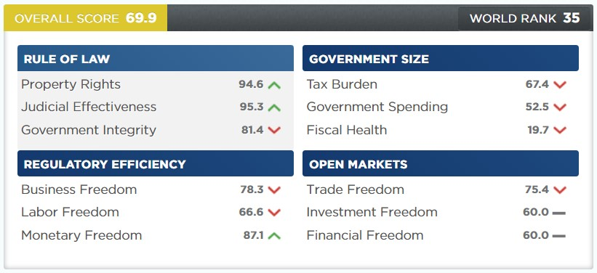

**Background:**

Japan has always dominated the global economy. Shinzo Abe served as prime minister for the greatest period of time in Japanese history until stepping down in September 2020. Yoshihide Suga, a former chief cabinet secretary, took over as his replacement but only served for a year before declining to run for office again. Fumio Kishida, a former foreign minister, was elected in October 2021 on a pledge to uphold Japan's foreign and security policy. Suga received harsh criticism for Japan's tardy response to the COVID-19 epidemic; however, Kishida now faces a better COVID scenario and has vowed to enact robust fiscal stimulus measures to jump-start Japan's lagging economy. The public wants significant reforms to address Japan's persistent economic issues, but they are concerned about the unrest that these changes would bring about.

**Rule of law:** Real estate secured interests are acknowledged and successfully enforced. The judiciary in Japan is impartial and independent. Although there is little corruption, a corporate environment that is friendly to favoritisms is fostered through strong ties between businesses, politicians, and government organisations. Amakudari, the practise of giving former government officials high positions in Japanese businesses, is widespread in several industries.

**Government Size:** Local taxes and an enterprise tax can dramatically boost the top individual income tax rate, which is 40.8 percent, and the top company tax rate, which is 23.9 percent. The entire tax burden is equivalent to 32.0% of the national income. Over the previous three years, government expenditure has totalled 39.8% of total production (GDP), while budget deficits have averaged 6.1% of GDP. GDP is equal to 256.2% of the public debt.

**Regulatory Efficiency:** The majority of state-owned businesses have been sold off. In 2020, the electricity sector reforms entered their third phase. A legislation was changed to require businesses to "make efforts" to hire people between the ages of 65 and 70 due to the declining labour force. Under the condition that such cars be charged with renewable energy, including solar electricity, the government has increased the value of subsidies intended to promote electric vehicles by a factor of two.

**Open Markets:** In force preferential trade agreements with Japan number 18. There are 401 nontariff measures in place, and the trade-weighted average tariff rate is 2.3 percent. In several industries, the government monitors foreign investment. Despite competition in the banking industry, government intervention continues. The amount of interest-free, no-collateral concessional loans offered by the government has increased, mainly for small and medium-sized businesses affected by the epidemic.

**Taxation:** The government's main source of income, taxes, make up the majority of its overall income. Since World War II, the tax system has been characterized by a large reliance on direct taxes, with the majority of tax revenues coming from steeply progressive income taxes on people and hefty corporation taxes. In order to improve the tax system, the majority of products and services began to be subject to an indirect consumption (value-added) tax in the late 1980s. The tax rate was initially set at 3 percent, but when it was raised to 5 percent in the late 1990s, the government overhauled the whole tax code, lowering tax rates, reducing the number of tax bands, adding new deductions, and eliminating other levies. The entire tax burden in Japan is significantly lower than it is in most other affluent nations relative to national income.

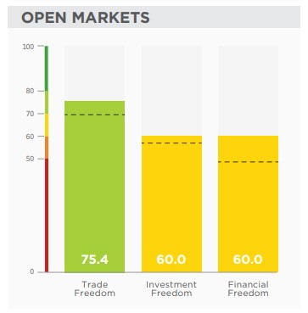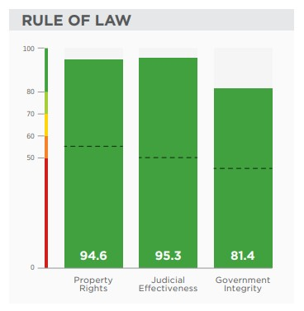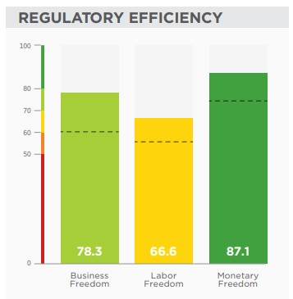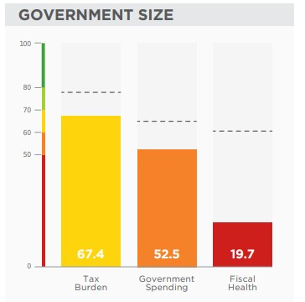

**External trade**

**Exports:**

Even while the percentage of exports in the nation's gross domestic product typically stayed relatively steady, Japan's quick growth in foreign sales was a notable aspect of the country's economic progress following World War II. However, exports are significantly more significant from the perspective of certain industries and as a driver of growth than their contribution to the national GDP would imply. Japan has enjoyed a trade surplus almost every year since the late 1960s, and the amount is frequently the biggest in the world. The diverse industrial output of Japan, the transition to goods with a relatively high value added, the nation's export competitiveness, and the industry's strong position in a number of industries are all factors in this exceptional export success. Japanese exports, however, confront more and more difficulties.

Most noted is the fierce rivalry from Southeast Asian nations as well as China, South Korea, and Taiwan, Japan's industrial neighbours. Other variables include the yen's value in relation to other currencies, the protectionist attitudes of Japan's main trade partners, and a decline in exports brought on by Japanese firms' increasing overseas manufacturing. Additionally, Japan's exports, particularly those of motor cars, are being significantly impacted by the global recession that started in 2007–2008. In the latter half of the 20th century, the export mix saw a significant transformation. The exports of a wide range of machinery and apparatuses (including electronic equipment and components) and transport equipment increased significantly, making up the greatest amount of all exports, while the exports of textiles and food goods significantly fell. Metals, chemical products, and chemicals were among the other significant exports. Japan's two biggest export markets are China and the US; other nations in East and Southeast Asia as well as the EU member states are also significant export destinations.

**Imports:**

Japan implemented stringent nontariff barriers and relatively high tariffs for several items after World War II to safeguard its home markets. High trade surpluses over time prompted Japan's trading partners, particularly the United States, to put more pressure on Japan to let foreign goods on its domestic market. The growth of imports has been steady as Japan's trading system has opened up. The majority of Japan's imports are energy, raw materials, and foodstuffs because of the country's limited natural resources. Machinery, ancillary items, and chemicals make up the majority of imported manufactured goods. East and Southeast Asia (particularly China), the Middle East, the United States, and Australia are among the top exporters to Japan.

**Internal trade:**

Japan has a long-standing, intricate wholesale distribution and retail marketing system that is characterized by a large number of intermediate tiers in the distribution of goods and tiny, frequently family-run retail establishments. The development of supermarket and discount shop chains, mail-order sales, and more lately, internet commerce have all posed threats to this structure, which has for years been threatened by Japan's huge department stores. Cash has always been used to make purchases; however, charge accounts and credit cards are also often used.

**Trade unions and employers’ associations:**

The history of labour unions in Japan is not very long. Even while there were a number of labour unions existing before World War II, trade unions didn't really take off until the American occupation forces passed laws granting employees the freedom to organize, engage in collective bargaining with their employers, and go on strikes. Japanese trade unions had a great number, and many times there were distinct organisations for various factories of the same firm since they were often structured on a plant or enterprise basis. Most enterprise unions joined federations that were informally structured along craft lines, such as the Confederation of Japan Automobile Workers' Unions (Jidsha Soren). The majority of them later joined one of the four important national labour unions that were founded after the war. The tendency toward ever-increasing industrial concentration and increased collaboration between the different employers' groups contributed significantly to the increase in interest in merging the opposing national organisations throughout the 1980s. The Japanese Trade Union Confederation (JTUC-Reng) was formed in the late 1980s from the reorganisation of the major national organisations and other private and public sector unions; the much smaller National Confederation of Trade Unions (Zenrren) was created by the unions that were politically more to the left of JTUC-Reng.

**ENVIRONMENTAL ANALYSIS OF JAPAN**

Early in the 1990s, Japan set lofty goals for climate preservation, and it remained committed to doing so throughout the decade. Japan has a comprehensive climate protection strategy, and it is well-coordinated and often evaluated. In accordance with the UN Framework Convention on Climate Change, Japan has continuously backed worldwide efforts to safeguard the environment (UNFCCC).

The economy's CO2 intensity (kg CO2/unit GDP) declined by 1.8% in the 1990s, moving it up to eighth place among OECD nations. Japan has worked to transition from oil to gas and nuclear electricity. Since the 1970s, it has made extensive and successful use of energy efficiency requirements, and in 1998, it established its "top-runner" programme, which greatly enhanced them. Major cities have well-developed public transportation systems with differential rates, and most metropolitan regions still rely heavily on public transportation for most passenger trips. Emissions of greenhouse gases (GHG) from this sector have decreased as a result of voluntary measures by the Japanese industrial sector. Public education campaigns encourage actions to combat global warming in order to change the behaviour of energy consumers.

One of the nations most impacted by catastrophes and natural disasters is Japan. Japan occasionally experiences tsunamis, floods, earthquakes, landslides, cyclones, and volcanic eruptions. Japan spent billions of dollars on reforms and reconstruction after these catastrophes. Japan really has less visitors due of natural calamities, expensive costs, and communication problems.

**TECHNOLOGICAL ANALYSIS:**

Japan has one of the most advanced telecommunications systems, in particular with their mobile gadgets. We within the west rely closely on texting considering statistics is monopolized with restrictions. Japan is the opposite; they have made it viable to connect with Wi-Fi absolutely anywhere in populated regions. So, as opposed to texting, the Japanese ship emails, and bypass touch information wirelessly by retaining their phones collectively.

Japan is captivated with the most up-to-date aspect and the modern-day era. Air conditioners are controlled by using remotes; televisions speak in English and Japanese; cars let you know where to head; and robots are everywhere. In automatic Japan, taxi doorways open and near robotically, airports are wiped clean with the aid of vacuum cleaners that perform without human assist and parking lots have talking price tag-taking machines. Japanese scientists are presently trying to expand cars which can drive themselves.

Japan’s talent for “monozukuri” (“component making”) has been a key to its fulfillment. Inside the vintage days, eastern thirst for brand new gadgets and new matters kept the enterprise going. Clients had the money and the proclivity to snatch up new gizmos that they quick tired of, desiring even more recent fashions, and a pool of engineers to preserve them satisfied. Ideas that stuck on had been promoted in distant places markets. Nowadays eastern keep on to their devices lengthy and have misplaced some of their enthusiasm for proudly owning the most modern component. Therefore, income has slackening in Japan and Japan has misplaced some of its side for arising with slicing area merchandise.

Japan’s getting old population is widely visible as an impediment to innovation. As the population gets older and fewer young people are born there are much less young people round to provide you with clean new thoughts and more cranky antique people round to pooh the fresh ideas that seem. There are greater engineers in Japan than the United States, even though the population of the U.S. is two times that of Japan. Japan often leads the world in patents. Eastern scientists have filed greater patent packages for superconductors than the relaxation of the sector combined. More than 600 have come from Sumitomo electric, Japan's leading manufacturer of electric wires and cables.

**CONCLUSION**

From the above macro environment analysis, it is clear that the Japan should more focus on the economical and trade sector to trade with in the international market as it plays the crucial role when it comes to the trading between the countries there are yet need of a revised outlier of the trading system, they should come up with some easy trading policies to eradicate the problem causing hindrance in the trading between the country.

Japan has a very developed sector for the tech companies they have come a long way in the field of technology. The kind of environment Japan has every country desire to have the same level of efficiency in their regulation. They have always ace in the field of tech giants. They should focus more on the technological sector too as they have specialization in them. Japan has a great human force with intellectuals who are capable enough to come up with their innovative ideas to give a cut throat competition on a world level so if they will focus more on enhancing the technological aspect of the world they can emerge as leading ambassador in the tech field.

# REFERENCE AND CITATION

* Cundiff, P., and Hilger, H. (1988) ‘*Marketing in the International Environment’* Prentice Hall Inc., Englewood Cliff, NJ.
* Czinkota, R. and Ronkainen, T. 1988. International Marketing. The Dryden Press, Chicago.
* Ellen, F., Jacofsky, John W. Slocum, Jr., and Sara J. McQuaid, (1988) ‘*Cultural Values and the CEO: Alluring Companions, Academy of Management Executive’* Vol: 2, No.1, pp 39-49.
* Ford & Honeycutt (1992) ‘*Japanese national culture as a basis for understanding Japanese business practices*’ Business Horizons
* Heiko, A. (1989) ‘*Some relationships between Japanese Culture and Just-intime. Academy of Management Executive*’ Vol: 3, No.4, pp 319-321
* Isamu, K., (1987) ‘*Japanese Identity. Fujitsu Institute of Management Press*’ Communicaid Group.
* Kanagawa, H., Nakayama, Y. (2012) ‘*international office law office’* Japan; academic press
* Kang, B. Gaishi, W. (1990) ‘*The Foreign Company in Japan. Basic Books*’ New York.
* Sekiguchi, K., Higashi, Y., Oyama, H., Hamada, M. (2021) ‘*practical law thomsonreuter’* available at https://uk.practicallaw.thomsonreuters.com/1519- 3917?transitionType=Default&contextData= (sc. Default) &firstPage=true
* Twosa, R., (2021) ‘*language insight’* Japan; public journal,available at <https://www.languageinsight.com/blog/2021/culture-business-japan-2/>
* Watanabe, D. (2017) ‘*three essential principles’* available at <https://www.japanindustrynews.com/2017/02/three-essential-principles->